# Abstract

**Background:** Health related quality of life following a stroke can vary greatly, and depends on how disabling the stroke is. The modified Rankin Scale (mRS) categorises disablement in seven discrete categories. By convention, the state following stroke is commonly categorised into three categories with cost-effectiveness models: death, dependent state, and independent state. A recent Medical Decision Making paper maps between EQ-5D utility and mRS score.

Objective: To explore a simulation approach for mapping utilities onto dependent and independent states using results presented in the MDM paper, and compare these estimate with existing utility estimates for dependent and independent states.

**Methods:** A statistical simulation based algorithm is developed and applied to map between mRS states onto dependent and independent states, using

Setting,

Patients,

Intervention (if any),

Measurements,

**Results,**

**Limitations,**

**Conclusions.**

# Structure

## Introduction

When constructing economic models, it is common for modellers only to have access to summary statistics reporting the costs or utilities of different health states. Sometimes the cost data might be reported for a different number of categories than the utility data. For example, there may be data available reporting the mean costs associated with a disease divided into four mutually exclusive states, and other data reporting utility scores associated with the same disease divided into six mutually exclusive states. When this occurs, the modeller either has to look for other sources of data which utilise the same categories, or is required to make assumptions about how the states relate to each other, introducing another layer of uncertainty into the construction of the model.

This paper describes a simulation-based approach for mapping utility scores reported for a larger number of states onto a smaller number of states, where the frequency of patients in each outcome state is also reported. The approach has been implemented in the statistical programming language R [reference], and the code is presented in the appendix to this paper. The approach is illustrated using two linked case studies. In the main case study, the aim is to associate utility states reported in six discrete states with costs associated with three states. In second case study, the aim is to map the same six utility states to five states. In the main case study, both the larger number and smaller number of states relate to outcomes following strokes. In the second case study, the aim is to map the larger number of states relating to outcomes following strokes to a slightly smaller number of states relating to outcomes following intracranial haemorrhage. These two case studies are linked because outcomes following strokes and outcomes following intracranial haemorrhages both need to be estimated when modelling the clinical and cost effectiveness of different oral anticoagulant treatment regimens for people identified as having a significant stroke risk [Ref?]. Oral anticoagulants, such as warfarin, reduce the risk of stroke but as a side effect can significantly increase the risk of intracranial haemorrhages (ICHs). As ICHs affect the brain, they can cause similar types and degrees of disablement to the strokes they are prescribed to prevent. Because of this, there are advantages to being able to base estimates of the utilities associated with states following strokes, and states following ICHs, on the same dataset, as this can improve the consistency of the mathematical model.

Within the main case study, a paper published in MDM by Rivero-Arias et al was used. [Ref] This paper presents the estimated mean EQ-5D utility scores for patients enrolled in the Oxford Vascular Study (OXVASC) study 24 months after a stroke, as associated with each of the six living modified Rankin Scale (mRS) states of disablement. Crucially, this paper also reports the number of patients who died as a result of the stroke, and the distribution of surviving patients by mRS state. The OXVASC study is a large scale and recent UK-based population cohort study. (1) Although the recent MDM papers reports utilities according to each of six living health states, cost data associated with outcomes following stroke often distinguish only between ‘dependent strokes’ and ‘independent strokes’. The approach uses the data published in the Rivero-Arias et al paper to estimate the utility scores associated with having either a ‘dependent stroke’ or ‘independent stroke’. In this case study, the utility estimates produced through the simulation approach are compared with those already available for these health states, but which are based on older data. [Ref Dornan.]

Within the second case study, descriptions of each of the mRS states are compared with descriptions of each of the Glasgow Outcome Scale (GOS) states used to categorise disablement following traumatic head injury. (2) Based on these descriptions a mapping between states is proposed, and the same approach is used to estimate the mean utilities associated with each GOS state.

## Method: What did we do?

### Introduce source paper

The mRS to EQ-5D mapping used data from the Oxford Vascular Study (OXVASC). OXVASC is a large scale population-based cohort, initiated in 2002, involving almost 100,000 individuals registered in Oxfordshire. The source paper used 1283 patients from this study, recruited between April 2002 and March 2007, who had suffered either stroke or transient ischemic attack (TIA). These patients were followed-up for up to 24 months following the stroke. The patients’ condition was assessed using the disease specific measure of the mRS, as well as the generic utility instrument EQ-5D. Based on this, the EQ-5D utilities associated with each state were estimated and reported.

### The Modified Rankin Scale, two state stroke categories, and the Glasgow Outcome Scale.

In order to use the approach, an informed decision must be made about how the scale with more categories maps onto scales with fewer categories. In the case studies, this decision is based on the verbal descriptions of different states for the three scales involved. The mRS is a commonly used measure of disability or dependence in daily activities following a stroke. It was introduced in its current form by van Swieten et al in 1988(3), and originally based on a 1957 paper by J Rankin.(4) The mRS is a seven level ordinal scale, with scores ranging from 0-6 inclusive, and has good inter-rater reliability.(5)

It is common within economic models for the live health states following strokes to be categorised as either the less severe ‘independent stroke’, or the more severe ‘dependent stroke’. [Reference needed]. Conventionally, ‘independent strokes’ are identified as mRS states 0-2, and ‘dependent strokes’ are categorised as states mRS states 3-5 [Reference]. The Glasgow Outcome Category has five distinct categories, including GOS 1, ‘dead’. GOS 2 is defined as a persistent vegetative state, and so is considered equivalent to death in terms of utility, though not in terms of cost. The mRS has the most categories, and so the purpose of the approach in these examples is to map from this scale onto the two other scales. Table 1 shows the three scales, and the equivalence relationships assumed between them:

[Table 1 about here]

### Graphical Representation of Algorithm

Within the primary case study, the aim of the approach is to map the seven mRS categories onto the three mutually exclusive states of ‘dead,’ ‘dependent’ and ‘independent’. The simulation approach used to map between the mRS states reported in Rivero-Arias et al 2010 to the three state categories is shown graphically in Figure 1 below. This describes both the statistical distributions used at each stage in the derivation, and the original data sources used within the Rivero-Arias et al paper.(1)

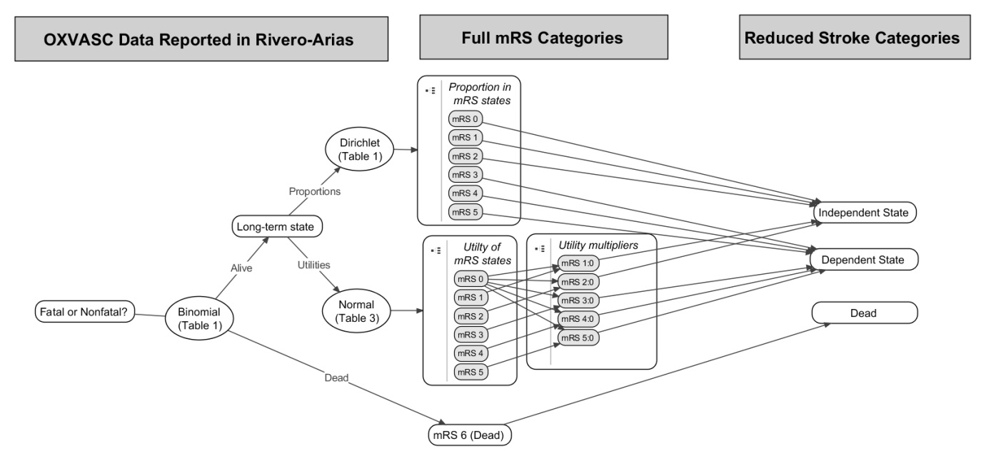

Figure Graphical representation of the mapping between states performed; table numbers refer to the tables in Rivero-Arias et al.

Uncertainty in the proportion of patients who survive a stroke was represented using a Binomial distribution. A Dirichlet distribution was used to represent uncertainty in the proportion of patients in each of the six mRS outcome states. These values were then converted back into estimated proportions of those alive in dependent and independent states following stroke. The code used to produce the mapping is presented in the appendix.

### Description of Data

Rivero-Arias et al reported that, of the 1,283 patients who had a stroke within the Oxford vascular study (OXVASc) cohort, 24.8% (319 / 1,283) were dead within 24 months. Of those who survived, mRS scores following the stroke was graded according to the modified Rankin Scale (mRS) 24 months after the event in 425 patients. For simplicity this 24 month state is assumed to be the patient’s long-term condition, and the patients for whom mRS outcomes were reported were assumed to be representative of those for whom the data were not collected. The ordinary least squares (OLS) based mean estimates for the utility associated with each state, combined with the standard deviations around these mean estimates, were also reported.

### Estimating proportions and utilities

As average utility differs by age, gender, and other characteristics,(6) utility multipliers, rather than the utility values themselves, were estimated from the above data in order to make the utility estimates more generalizable to other populations. As the mildest of the categories, mRS 0, is a full recovery, this is assumed to represent baseline patient utility. Multipliers for mRS 1-5 were thus calculated by dividing utility estimates of these worse states by the utility estimates of mRS 0.

Uncertainty in both numerators and denominators were estimated using a simulation approach, with 10,000 random draws from EQ-5D estimates of each of the states mRS 1-5 divided by 10,000 random draws from the EQ-5D estimates for state mRS 0. Although increasing the number of random draws would, on average, lead to greater precision in terms of the simulation error associated with the estimation of any given quantile (such as the median score, the 2.5% centile and the 97.5% centile), the number of draws should not lead to biased estimates of these quantiles.

In order to derive estimates of the utility multiplier associated with both dependent and independent strokes, the proportion of each of the constituent mRS states within the dependent and independent stroke category needs to be estimated. Uncertainty in our knowledge of these proportions thus also needs to be represented. This is done as follows:

1. Sample from a Dirichlet distribution with all six mRS states;
2. Divide the six states into the independent stroke category (mRS 0-2) and dependent stroke category (mRS 3-5);
3. Calculate the relative proportion of mRS states 0-2 within the independent stroke category, and relative proportion of mRS states 3-5 within the dependent stroke category;
4. Weight utility multiplier estimates of mRS states 0, 1, and 2 in proportion to these states’ relative prevalence within the independent stroke category; and weight utility multiplier estimates of mRS states 3, 4, and 5 in proportion to these states’ relative prevalence within the dependent stroke category.

To estimate uncertainty around the mean utility multiplier for dependent and independent stroke multipliers, the mean values of the bootstraps of the distributions produced was then calculated in order to estimate both the means and uncertainty around the means. By using bootstrapping at this stage, we are able to avoid the large standard deviations associated with the small sample sizes of some of the outcome categories leading to over-inflated estimates of uncertainty, which suggest either that the plausible range of uncertainty in our mean utility estimates for dependent states exceeds that of independent states a significant proportion of the time, or predicts utility scores of above one.

For simplicity, it was assumed that patients who sustained a stroke that caused mortality accrued no further QALYs. This is a limitation as not all patients would have died instantly. However, data were not identified that could be used to accurately populate this parameter.

The approach adopted for mapping between mRS states and GOS states is directly equivalent, but involves mapping onto the five GOS states rather than three states, as described in Table 1.

### Comparison with previous estimates

For the main case study, estimates of the utility associated with dependent and independent stroke states were compared with those previously published and used in health technology assessments [references]. These estimates were based on older data in a different patient population, reflecting outcomes following treatment regimens which may not be reflective of current practice, and so discrepancies between these and the simulated results should be expected. Where such discrepancies exist, however, the reasons for them should be clinically and statistically plausible.

## Results: What did we find?

### Proportion of live patients in dependent and independent states

Of those with mRS states recorded at 24 months, 74.1% of those living after a stroke were in an independent state, and 25.9% were in a dependent state. The distribution of mRS states within each of the higher level dependent and independent stroke categories is heavily skewed, as indicated in Figure 2. This provides evidence of the need to take into account the weighting of the various distribution of mRS states within both the dependent stroke and independent stroke categories.

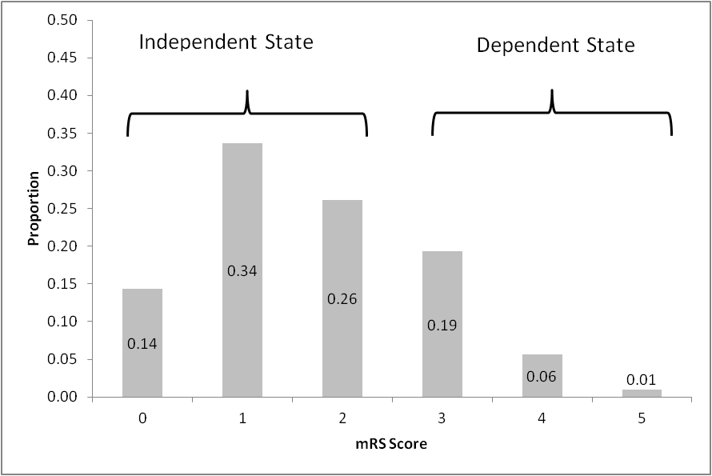

Figure Distribution of stroke outcomes at 24 months, in survivors at 24 months only

### Simulated proportions of patients in each of the three states

Using the simulation approach described above, the estimated proportion of long term outcomes following a stroke in each of the three states, together with 95% credible intervals, is shown in Figure 3.

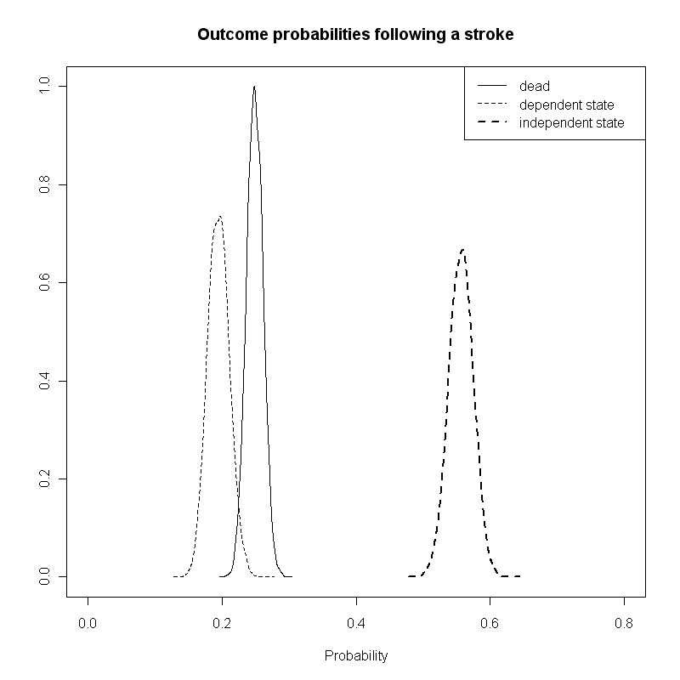

Figure The estimated distribution of patient health states 24 months after a stroke

### Estimated utility associated with dependent and independent states

Using the approach described above, our central estimates for the utility associated with two states are as follows: for independent strokes, the estimated utility multiplier was 0.822 (boostrapped 95% credible interval of 0.819 to 0.824); for independent strokes, the estimated utility multiplier was 0.482 (bootstrapped 95% credible interval of 0.477 to 0.487). The similarities and differences between these estimates and estimates previously produced are discussed below.

### Comparison between simulated utilities and results previously published at this level of disaggregation

Our estimated utility multipliers are very similar to those presented in Dorman et al.,149 for independent strokes but somewhat higher than those reported in that paper for dependent strokes. This is largely due to the distribution of mRS states within the Independent Stroke and Dependent Stroke categories, which for both categories of stroke are weighted towards less severe mRS states (as shown in Figure 2). In the case of dependent strokes (mRS 3-5), for example, only around 4% were the worst category mRS 5, which has an estimated EQ-5D score around zero, and around 75% were in the least worst category mRS 3, which has an estimated EQ-5D score over 0.5. The discrepancy may reflect improvements in the prognosis following strokes in the decade that separates the studies used.

### Secondary Objective: estimated utilities following an intracranial haemorrhage

Using the same approach, but mapping onto the five GOS states rather than the three stroke states, the following utility multiplier estimates were produced: Both GOS 1 (dead) and GOS 2 (vegetative state) were assumed to be equivalent, and confer no utility. GOS 3 (‘severely disabled’) had an estimated utility multiplier of 0.226 (bootstrapped 95% credible interval of 0.221 to 0.231), G0S 4 (‘moderately disabled’) had an estimated utility multiplier of 0.642 (95% credible interval of 0.638 to 0.645); and GOS 5 (‘good recovery’) had an estimated utility multiplier of 0.895 (95% credible interval of 0.892 to 0.898).

### Summary

## Discussion:

### Para 1: Brief synopsis of key findings, with particular emphasis on how the findings add to the body of pertinent knowledge

This paper shows that it is possible to make use of cost and utility data associated with a particular health state or range of health states even where such data (cost and utility data) are presented to differing levels of disaggregation. Because of this, it is possible to make use of more recent and /or more pertinent data to inform the economic model than was previously possible using summary data alone. The approach involves making a number of assumptions, but these assumptions are clearly stated and can be developed and improved upon where additional clinical and statistical data allow it. These are discussed in more detail in the implications for research section below. In the case studies provided the approach was shown to be able to make use of the same population to inform both the utility consequences of strokes, and the utility consequences of intracranial haemorrhages which may result from prescribing oral anticoagulants to try to present strokes, allowing a model based on such data some level of greater consistencyThe approach can be applied to other similar situations, provided the right form of summary data exist, which report the frequency of patients in different states, as well as the utilities associated with each state.

### Para 2: Possible mechanisms and explanations for the findings

### Para 3: Compare study results with relevant findings from other published work

In the primary case study, the approach was able to produce simulated values for the utilities associated with independent strokes and dependent strokes that were consistent with those previously published and used, but which seem more reflective of improved outcomes following better clinical management of stroke patients. This highlights the importance of making use of more recent data where possible, given that healthcare systems change and improve; to do otherwise may be misrepresenting the costs and clinical consequences of modern treatment regimens for particular conditions. Existing sources of utility estimates following stroke based on studies conducted some time ago [ref]. Outcomes following stroke may have changed since due to improvements in patient management.

### Para 4: Limitations of the present study and any methods used to minimize or compensate for those limitations

The approach described here cannot be expected to produce perfect estimates of costs and utilities associated with outcomes. Instead the aim is to make better use of existing summary data. Without individual level data reporting all outcomes of interest in terms of costs and utilities in the same population, there will always be errors and biases associated with the estimates. There are reasons to expect that the simulation approach described here will be better than alternative approaches in some situations but not others. For example, in the case of the case study, data were available in the required number of states that were relatively old, and in more states based on much more recent data. The older data estimates were based on an individual patient level analysis of the older data, whereas the estimates produced here were based on a reconstruction of summaries of newer data. The additional assumptions required to produce the simulation introduce additional sources of potential error and bias into the estimates, but on the other hand allow use of a dataset which may be much more pertinent to the decision problems of interest. The decision whether to base the estimates on older or less pertinent data without making the additional assumptions implicit here, or to use the simulation approach here and make use of more pertinent data, is a matter of modeller judgment which should be informed by a clinical understanding of the subject area.

Assumptions involved in producing the simulations include: the need to assume perfect mapping (or ‘bijection’) between health states based on descriptions of states, and the choice of normal distributions as the distributions to simulate from. In both cases, alternative assumptions could be made, and where they are not the fact these assumptions is made explicit and open to further investigation.

The bijection assumption should represent the best assumption of the economic modeller based on clinical knowledge, and where other clinical evidence and opinion exists which suggests alternative mapping arrangements should be considered or used instead, the effect of making these assumptions on the modelling results and utility/cost estimates should be explored and presented where possible.

The effect of using a normal distribution, and the other choices of distribution indicated in this paper, should also be explored, and the effect of these assumptions on the estimates made explicit. It is known, for example, that the normal distribution is not bounded between any two particular values, whereas the EQ-5D utility values which are mapped onto the mRS states are known to be bounded between approximately -0.54 and 1. Where the values from the simulation fall outside these limits, it may be appropriate to resample from the distribution, or to consider the use of alternative distributions for representing this variation.

In terms of the source data used, it is known that EQ-5D data are only poorly approximated by the Normal distribution, as the distribution of EQ-5D is typically known to be ‘multimodal’. This represents a more general limitation common to a range of modelling approaches, rather than something specific to this approach.

Due to a paucity of information to suggest otherwise, a number of assumptions had to be made in the case studies discussed. For example, this 24 month state reported in the Rivero-Arias paper was assumed to be the patient’s permanent state until another event occurs, and the patients for whom mRS outcomes were reported were assumed to be representative of those for whom the data were not collected. Additionally, it was assumed that all patients who died of strokes died instantly, which will underestimate both the costs and utilities associated with this event. There are also potential issues of generalisability when applying estimates based on a sample of the OXVASc study population to other patient populations, especially if adapting models based on these estimates to other countries.

### Para 4: Any crucial future research directions

A range of further research directions are possible based on this approach. The most important of these is to attempt to verify the accuracy of this approach using individual patient data where the true answers are already known. The comparison presented in this paper was unable to do that because the results were based on different studies. Research should also be conducted to try to identify the most appropriate way of applying this form of approach to a range of clinical areas, including the most appropriate choice of distributions and bijection assumptions to make.

The main purpose of the approach described here is to make sure that decision models are based on all pertinent available information, and are not limited by lack of clear interoperability between costs and utility summaries. The effectiveness of this approach should be judged on whether it offers an improvement on current practice, rather than whether it produced the most accurate summary estimates theoretically possible.

In the clinical area considered in the case study, it may also be valuable to see how the model could be applied to summary data which report either mean cost or utility data using the Barthel index, which is also commonly used in this area. If mapping from either categorisation system to the same categorisation system yields similar results when based on the same or similar population, then this would provide further evidence in support of the validity of the approach described here.

### Conclusions: Conclude with a brief section that summarises in a straightforward manner the clinical implications of the work.

The implications for clinical practice of this research are subtle, but have the potential to be significant. The choice of cost and utility estimates in cost effectiveness models affects the results they produce, which in turn has the potential to affect the decisions made by healthcare reimbursement agencies like NICE, and so the range and quality of the healthcare experienced by patients. An implication of this model for cost-effectiveness models is that, if the modeller chooses to accept the limitations of the method used to produce them, a newer set of utility multiplier estimates are available to modellers using mathematical models which involve strokes and different stroke categories as health states. The approach described also could be adapted to other datasets in other clinical areas. The validity and attractiveness of this approach in comparison to the alternatives needs further investigation and consideration.

## Appendix

The R code used to produce the above simulations is reproduced below:

# This function produces bootstrapped CIs of means of a vector

Bootstrapper <- function(inputs, simulates = 10000){

X.mean <- vector("numeric", simulates)

N.inputs <- length(inputs)

for (i in 1:simulates) {X.mean[i] <- mean(inputs[sample(1:N.inputs, replace=T)])}

return(X.mean)

}

require(MCMCpack)

N.PSA <- 10000

# Dead/nondead following stroke:

# from Table 1: 319 dead out of 1283

Dead_nonDead <- rbinom(N.PSA, 1283, (319/1283)) / 1283

# mRS following stroke, if not dead

# from Table 1, 24 months

mRS_followingStroke <- rdirichlet(N.PSA, c(61, 143, 111, 82, 24, 4))

# three state reduction:

DepInd_followingStroke <- cbind(apply(mRS_followingStroke[,1:3], 1, sum), apply(mRS_followingStroke[,4:6], 1, sum))

DeadDepInd_followingStroke <- cbind(Dead_nonDead, (1 - Dead_nonDead) * DepInd_followingStroke[,1], (1-Dead_nonDead) * DepInd_followingStroke[,2])

apply(DeadDepInd_followingStroke,2, mean)

colnames(DeadDepInd_followingStroke) <- c("Dead", "Independent", "Dependent")

# Using table 3 (24 months column) from Rivero-Arias

s0 <- rnorm(N.PSA, .959, .074)

s1 <- rnorm(N.PSA, .812 , .181)

s2 <- rnorm(N.PSA, .656, .218)

s3 <- rnorm(N.PSA, .545, .277)

s4 <- rnorm(N.PSA, .248, .281)

s5 <- rnorm(N.PSA, .020, .046)

mult.s1 <- s1/s0

mult.s2 <- s2/s0

mult.s3 <- s3/s0

mult.s4 <- s4/s0

mult.s5 <- s5/s0

Stroke.Ind <- mRS_followingStroke[,1:3]

Stroke.Dep <- mRS_followingStroke[,4:6]

Stroke.Dep.sums <- apply(Stroke.Dep, 1, sum)

Stroke.Ind.sums <- apply(Stroke.Ind, 1, sum)

Stroke.Dep <- apply(Stroke.Dep, 2, function (x) x / Stroke.Dep.sums)

Stroke.Ind <- apply(Stroke.Ind, 2, function (x) x / Stroke.Ind.sums)

Stroke.Ind.utils <- Stroke.Ind[,1] * 1 + Stroke.Ind[,2] * mult.s1 + Stroke.Ind[,3] * mult.s2

Stroke.Dep.utils <- Stroke.Dep[,1] * mult.s3 + Stroke.Dep[,2] * mult.s4 + Stroke.Dep[,3] * mult.s5

n.bootstraps <- 10000

Stroke.Ind.utils.mean <- vector("numeric", n.bootstraps)

Stroke.Dep.utils.mean <- vector("numeric", n.bootstraps)

for (i in 1:n.bootstraps){Stroke.Ind.utils.mean[i] <- mean(Stroke.Ind.utils[sample(1:N.PSA, n.bootstraps, replace=T)])}

for (i in 1:n.bootstraps){Stroke.Dep.utils.mean[i] <- mean(Stroke.Dep.utils[sample(1:N.PSA, n.bootstraps, replace=T)])}

Stroke.Ind.utils.mean <- Bootstrapper(Stroke.Ind.utils)

Stroke.Dep.utils.mean <- Bootstrapper(Stroke.Dep.utils)

GOS_5 <- mRS_followingStroke[,1:2]

GOS_4 <- mRS_followingStroke[,3:4]

GOS_3 <- mRS_followingStroke[,5:6]

GOS_5.sums <- apply(GOS_5, 1, sum)

GOS_4.sums <- apply(GOS_4, 1, sum)

GOS_3.sums <- apply(GOS_3, 1, sum)

GOS_5 <- apply(GOS_5, 2, function (x) x / GOS_5.sums)

GOS_4 <- apply(GOS_4, 2, function (x) x / GOS_4.sums)

GOS_3 <- apply(GOS_3, 2, function (x) x / GOS_3.sums)

GOS_5.utils <- GOS_5[,1] * 1 + GOS_5[,2] * mult.s1

GOS_4.utils <- GOS_4[,1] * mult.s2 + GOS_4[,2] * mult.s3

GOS_3.utils <- GOS_3[,1] * mult.s4 + GOS_3[,2] * mult.s5

GOS_5.mean <- vector("numeric", n.bootstraps)

GOS_4.mean <- vector("numeric", n.bootstraps)

GOS_3.mean <- vector("numeric", n.bootstraps)

for (i in 1:n.bootstraps){

GOS_5.mean[i] <- mean(GOS_5.utils[sample(1:N.PSA, n.bootstraps, replace=T)])

GOS_4.mean[i] <- mean(GOS_4.utils[sample(1:N.PSA, n.bootstraps, replace=T)])

GOS_3.mean[i] <- mean(GOS_3.utils[sample(1:N.PSA, n.bootstraps, replace=T)])

}

# Notes

* Each paragraph should start with a clear message (a ‘topic sentence’)
* Try to do each paragraph in one go (for consistency)

# Editing

## Micro-editing

### Is the information correct?

### Are requirements stated in ‘Instructions to authors’ met?

### Is the English clear and simple?

### Is the grammar and spelling correct?

## Macro-editing

### Is there a clear message?

#### Is there a clear message?

#### Is the message worth giving?

#### Is the message proven?

#### Where does the message appear

### Is the market appropriate?

### Is the structure appropriate?

#### Does it follow IMARD structure?

#### Are paragraphs clearly written?

### Is the tone appropriate?

## Yellow marker test

### Highlight most important sentences

#### Are the first sentences of paragraphs highlighted? (Otherwise meaning may be buried)

# References

1. Rivero-Arias O, Ouellet M, Gray A, Wolstenholme J, Rothwell PM, Luengo-Fernandez R. Mapping the Modified Rankin Scale (mRS) Measurement into the Generic EuroQol (EQ-5D) Health Outcome. Medical Decision Making [Internet]. 2010;30(3):341–54. Available from: <Go to ISI>://000277892800009

2. Jennett B, Bond M. Assessment of outcome after severe brain damage. Lancet [Internet]. 1975 Mar 1 [cited 2012 Apr 4];1(7905):480–4. Available from: http://www.ncbi.nlm.nih.gov/pubmed/46957

3. van Swieten JC, Koudstaal PJ, Visser MC, Schouten HJ, van Gijn J. Interobserver agreement for the assessment of handicap in stroke patients. Stroke [Internet]. 1988 May 1 [cited 2012 Mar 18];19(5):604–7. Available from: http://stroke.ahajournals.org/cgi/doi/10.1161/01.STR.19.5.604

4. RANKIN J. Cerebral vascular accidents in patients over the age of 60. II. Prognosis. Scottish medical journal [Internet]. 1957 May [cited 2012 Apr 4];2(5):200–15. Available from: http://www.ncbi.nlm.nih.gov/pubmed/13432835

5. Wilson JTL, Hareendran A, Hendry A, Potter J, Bone I, Muir KW. Reliability of the modified Rankin Scale across multiple raters: benefits of a structured interview. Stroke; a journal of cerebral circulation [Internet]. 2005 Apr [cited 2012 Apr 4];36(4):777–81. Available from: http://www.ncbi.nlm.nih.gov/pubmed/15718510

6. Ara R, Brazier JE. Populating an economic model with health state utility values: moving toward better practice. Value in health : the journal of the International Society for Pharmacoeconomics and Outcomes Research [Internet]. 2010 Aug [cited 2012 Apr 4];13(5):509–18. Available from: http://www.ncbi.nlm.nih.gov/pubmed/20230546

# Tables

|  |  |  |  |  |
| --- | --- | --- | --- | --- |
| **mRS Score** | **Category** | **Description** | **Reduced Category** | **Glasgow Outcome Scale State** |
| 0 | No Symptoms | No symptoms at all. | Independent stroke | GOS 5: Good Recovery |
| 1 | No Significant Disability | No significant disability despite symptoms; able to perform all usual duties and activities. |
| 2 | Slight Disability | Slight disability; unable to perform all normal activities but able to look after own affairs without assistance | GOS 4: Moderately disabled |
| 3 | Moderate Disability | Moderate disability requiring some help but able to walk without assistance. | Dependent stroke |
| 4 | Moderately Severe Disability | Moderately severe disability; unable to walk without assistance and unable to attend to own bodily needs without assistance. | GOS 3: Severely disabled |
| 5 | Severe Disability | Severe disability; bedridden, incontinent, and requiring constant nursing care and attention. |
| 6 | Dead | Dead | Dead | GOS 1: Dead;  GOS 2: Vegetative state |

Table The modified Rankin Score (mRS) categories, and assumed mapping between mRS states and reduced stroke categories and Glasgow Outcome Scale (GOS) states